## **KPI’s**

**1. Total Loan Applications**



Month-to-Date Loan Applications

Previous Month-to-Date Loan Applications

Month-to-Month Changes

**2. Total Funded Amount**



Month-to-Date

Month-to-Month Changes

**3. Total Amount Received**



Month-to-Date

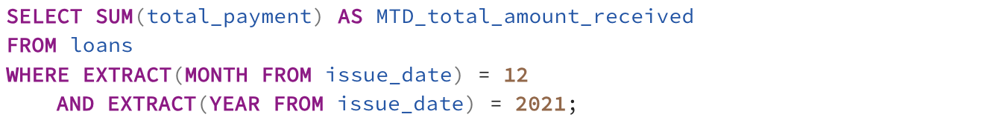

Month-to-Month Changes

**4. Average Interest Rate**



Month-to-Date

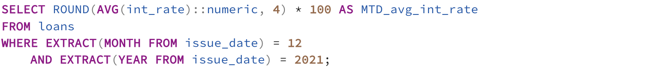

MoM Changes

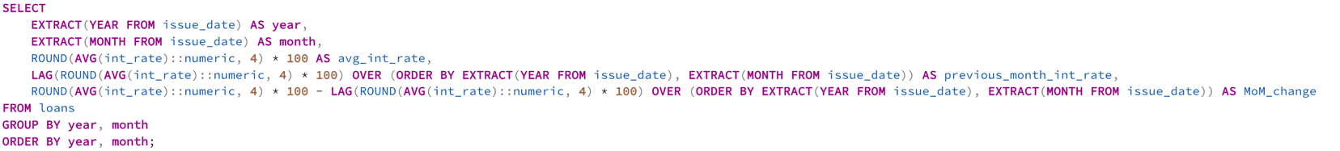

**5. Average Debt-to-Income (DTI) Ratio**



Month-to-Date



MoM Changes

## **Good Loans**

1. Good Loan Application Percentage

2. Good Loan Applications

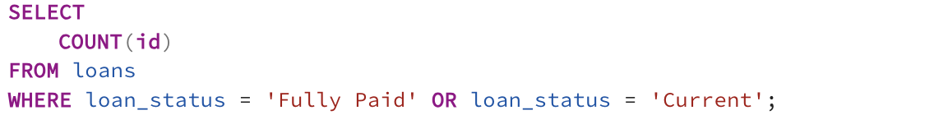

3. Good Loan Funded Amount

4. Good Loan Total Received Amount

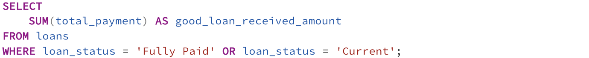

The received amount is more than the funded (or, invested) amount in good loans. This means the bank is making profit from good loans.

## **Bad Loans**

1. Good Loan Application Percentage

2. Bad Loan Applications

3. Bad Loan Funded Amount

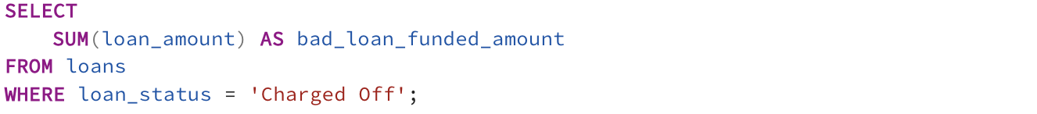

4. Bad Loan Total Received Amount

The banks are losing money as the customers are not paying back their loans/installments. We suggest further investigations into the customers, such as credit reports and scores.

## Loan Status

## Monthly Trends by Issue Date

To identify seasonality and long-term trends in lending activities.

## Regional Analysis by State

To identify regions with significant lending activity and assess regional disparitites.

## Loan Term Analysis

Allow client to understand the distribution of loans across various term lengths.

## Employee Length Analysis

How lending metrics are distributed among borrowers with different employment lengths, helping us to assess the impact of employment history on loan applications.

## Loan Purpose Breakdown

A visual breakdown will be provided in Tableau on the loan metrics based on stated purposes of loans, aiding in the understanding of the primary reasons borrowers seeking financing.

## Home Ownership Analysis

For a hierarchical view of how home ownership impacts loan applications and disbursements.

